Printing to Labels
You can print to various sized labels on your Canon device using the Multi-purpose tray.
Step 1: From a Microsoft Word document, select the Mailings Tab.
- From the Mailings Tab, select Labels.
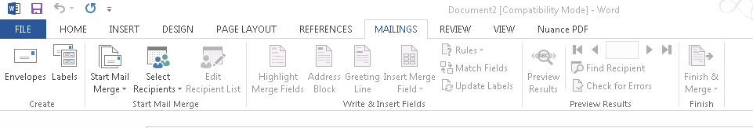
Step 2: From the Labels Tab, enter what you would like to put in the Address Field.
- Click on the Label Location in the window and it will allow you to select the brand of labels you are printing on.
- From the Label Options, verify that the label sheets are being pulled from the Multi-purpose tray (you will be prompted to select the “Labels” option in the printer prior to starting).
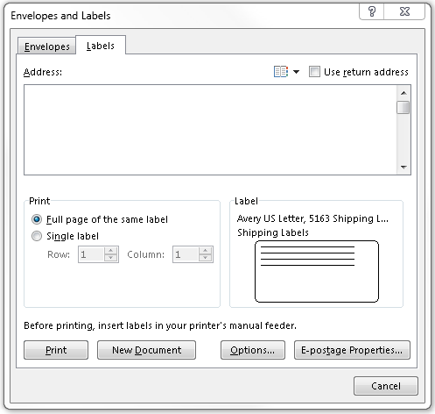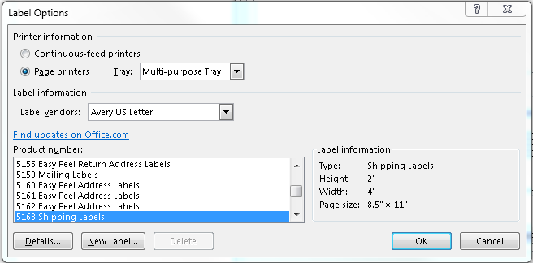
Step 3: Load your Labels into the Multi-function tray and click Print.
- Your labels should now be ready to pick up at your Canon device.

